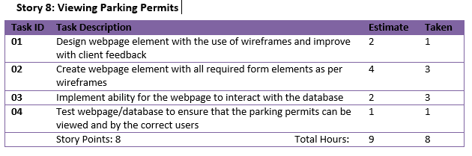Group 118 – Release 2 Acceptance Testing

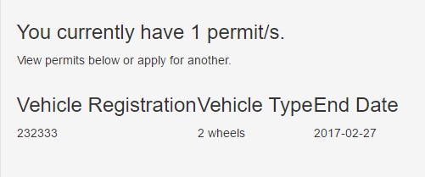

The above demonstrates User Story 8 by using a tabular format to allow users and department workers to view successfully registered parking permits. This will only be displayed if the current user has parking permits registered at the time.

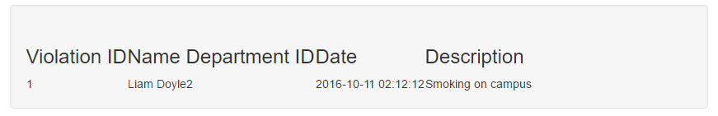

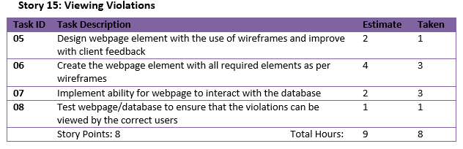 When a user logs into the website, they are taken to the homepage which will clearly display whether or not they have any health violations against them and if so will present them with the information about the violation

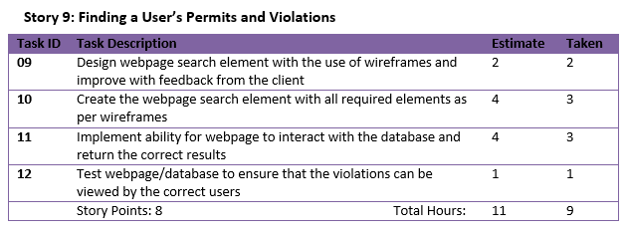

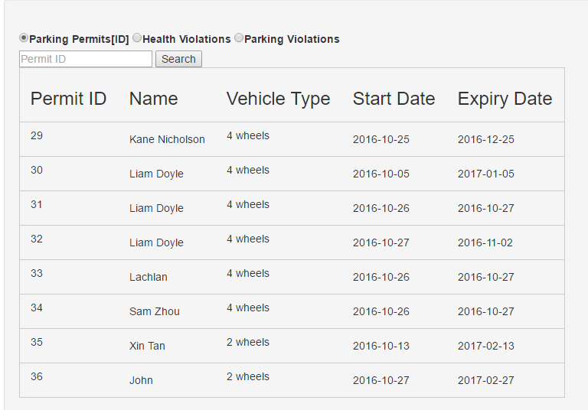

As displayed above, an admin account (admin account details are available in the .txt in the Release 2 archive) is able to use the search page to search for Parking Permits by user ID, Health Violations by Violation ID and Parking Violations by Citation ID. This enables the department staff to quickly locate a certain permit or violation even when there are many in the database.

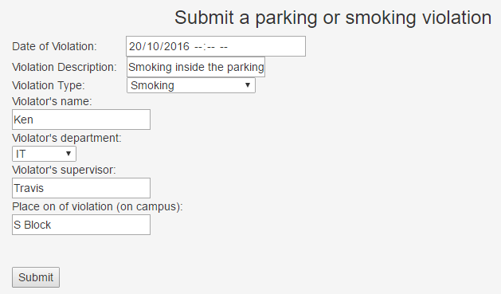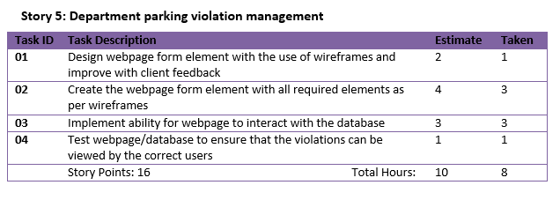The Department (Admin account) is able to use this dynamic violation submission form to report and record any violation of health or parking that occurs within the campus. Depending on the type of violation, the form will update with the necessary information boxes to allow the Department worker to efficiently submit a violation report.

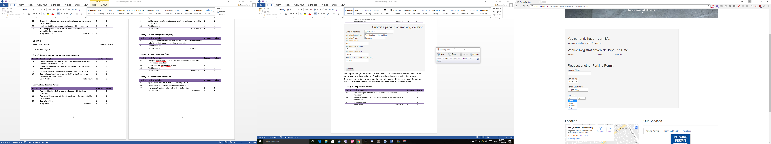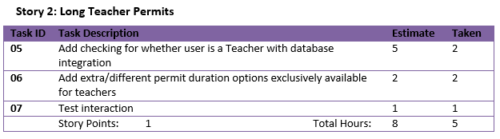

If the account logged in is a teacher, they have access to extra Parking Permit durations considering that they will need to be constantly coming into the college and shouldn’t need to worry about having to constantly apply for parking permits.

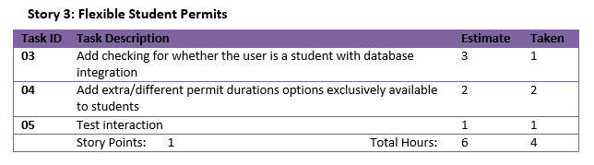

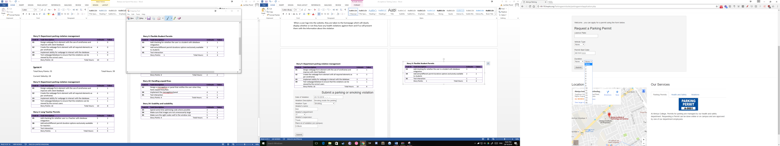If the account that is logged in is a student account, they will have access to more versatile options when they register for a parking permit at the college, allowing them to tailor their permit to their needs.

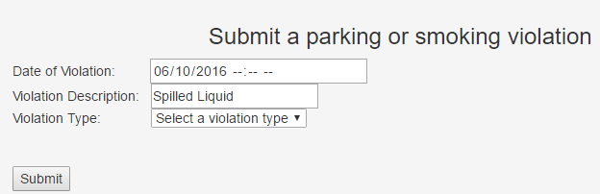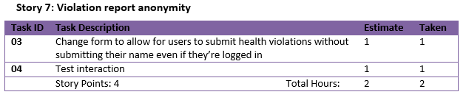

Anybody can anonymously submit a health violation to the department even without an account to make sure that if the user doesn’t want their details to be known they can still submit a violation. Even if the user has a registered account and is logged in, they will not be required to enter their name and it will not be automatically recorded from their login details.

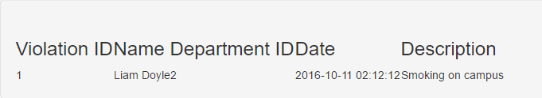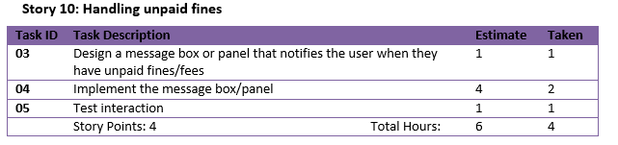This user story was not entirely completed as there is no message box presentation to notify the user if they have any unpaid fines or violations against them. Instead when they login and are directed to the homepage they will be shown what violations and unpaid fines they have against them in tabular form that will also include and overdue date so that the user knows they have an outstanding fine to pay.

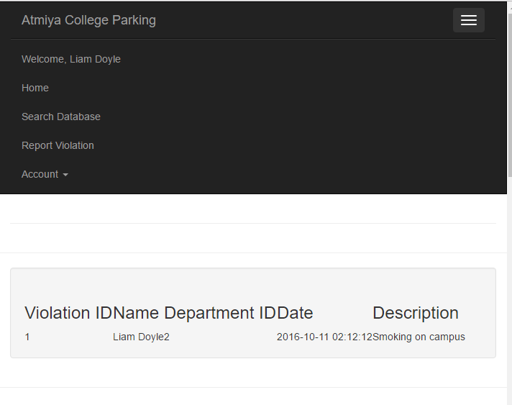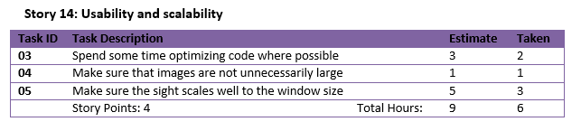

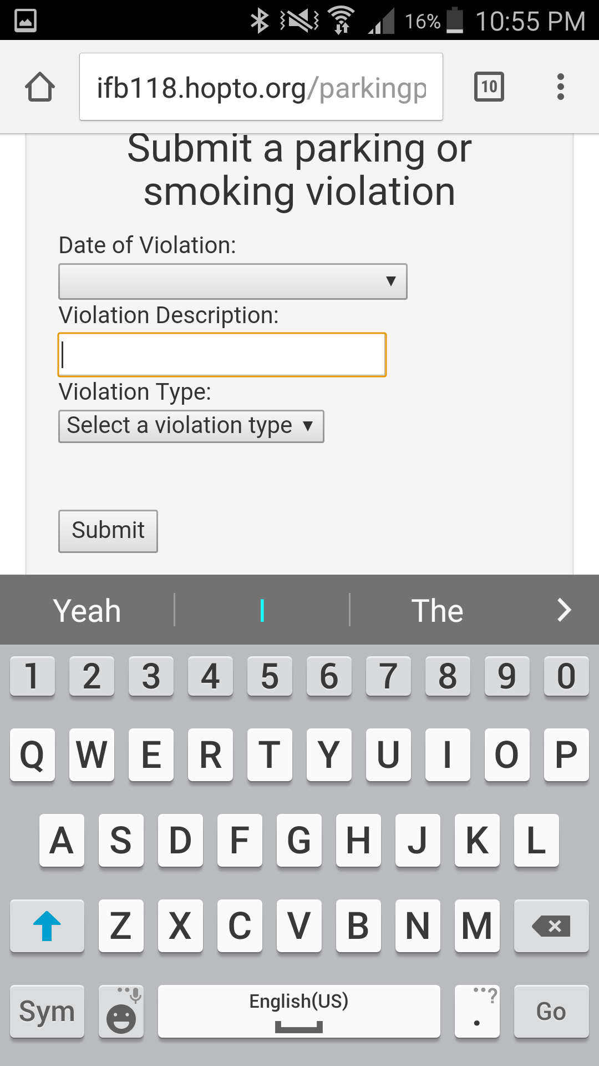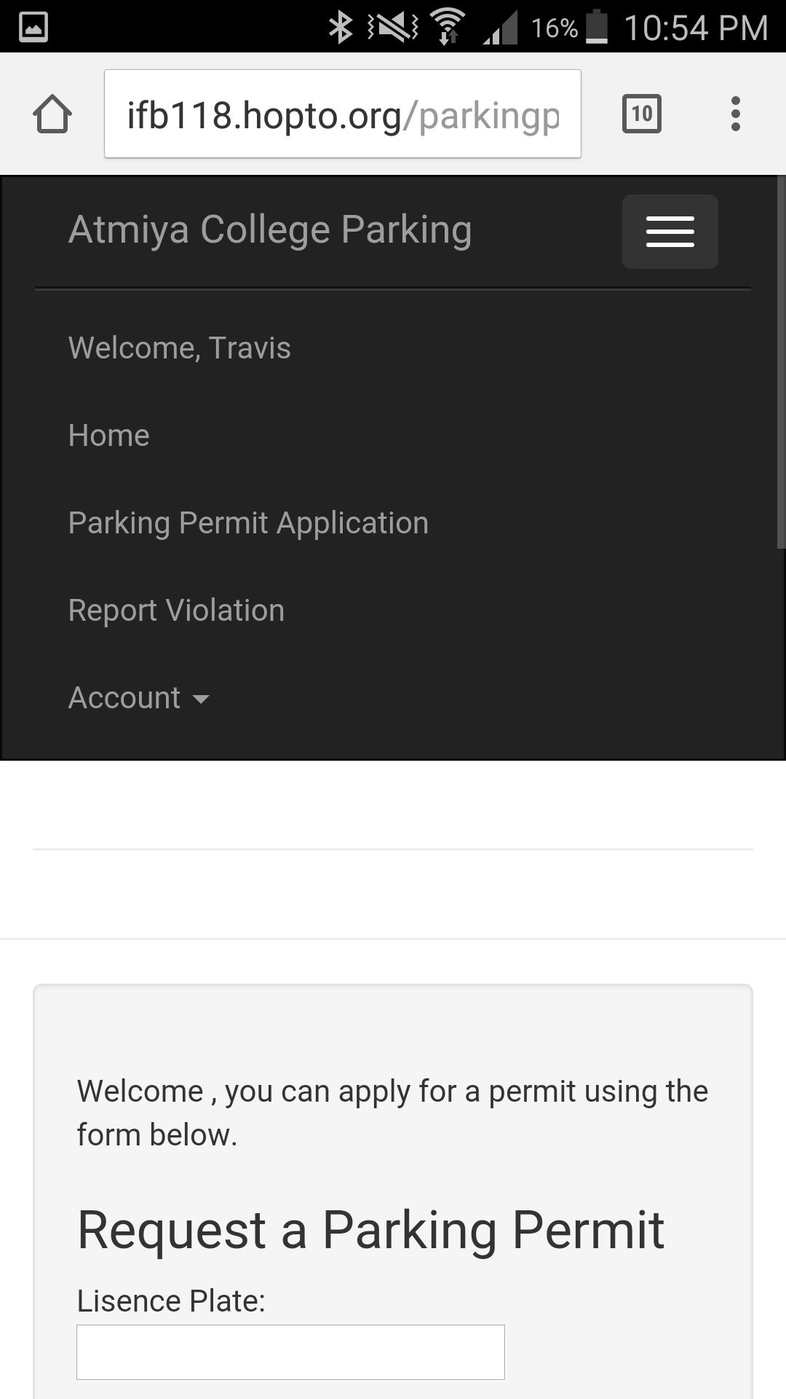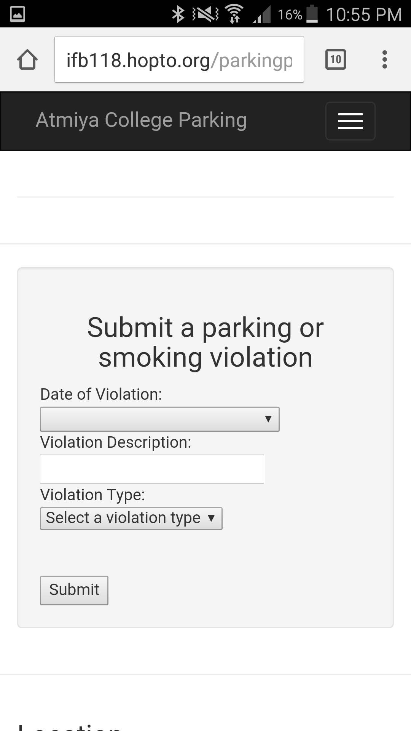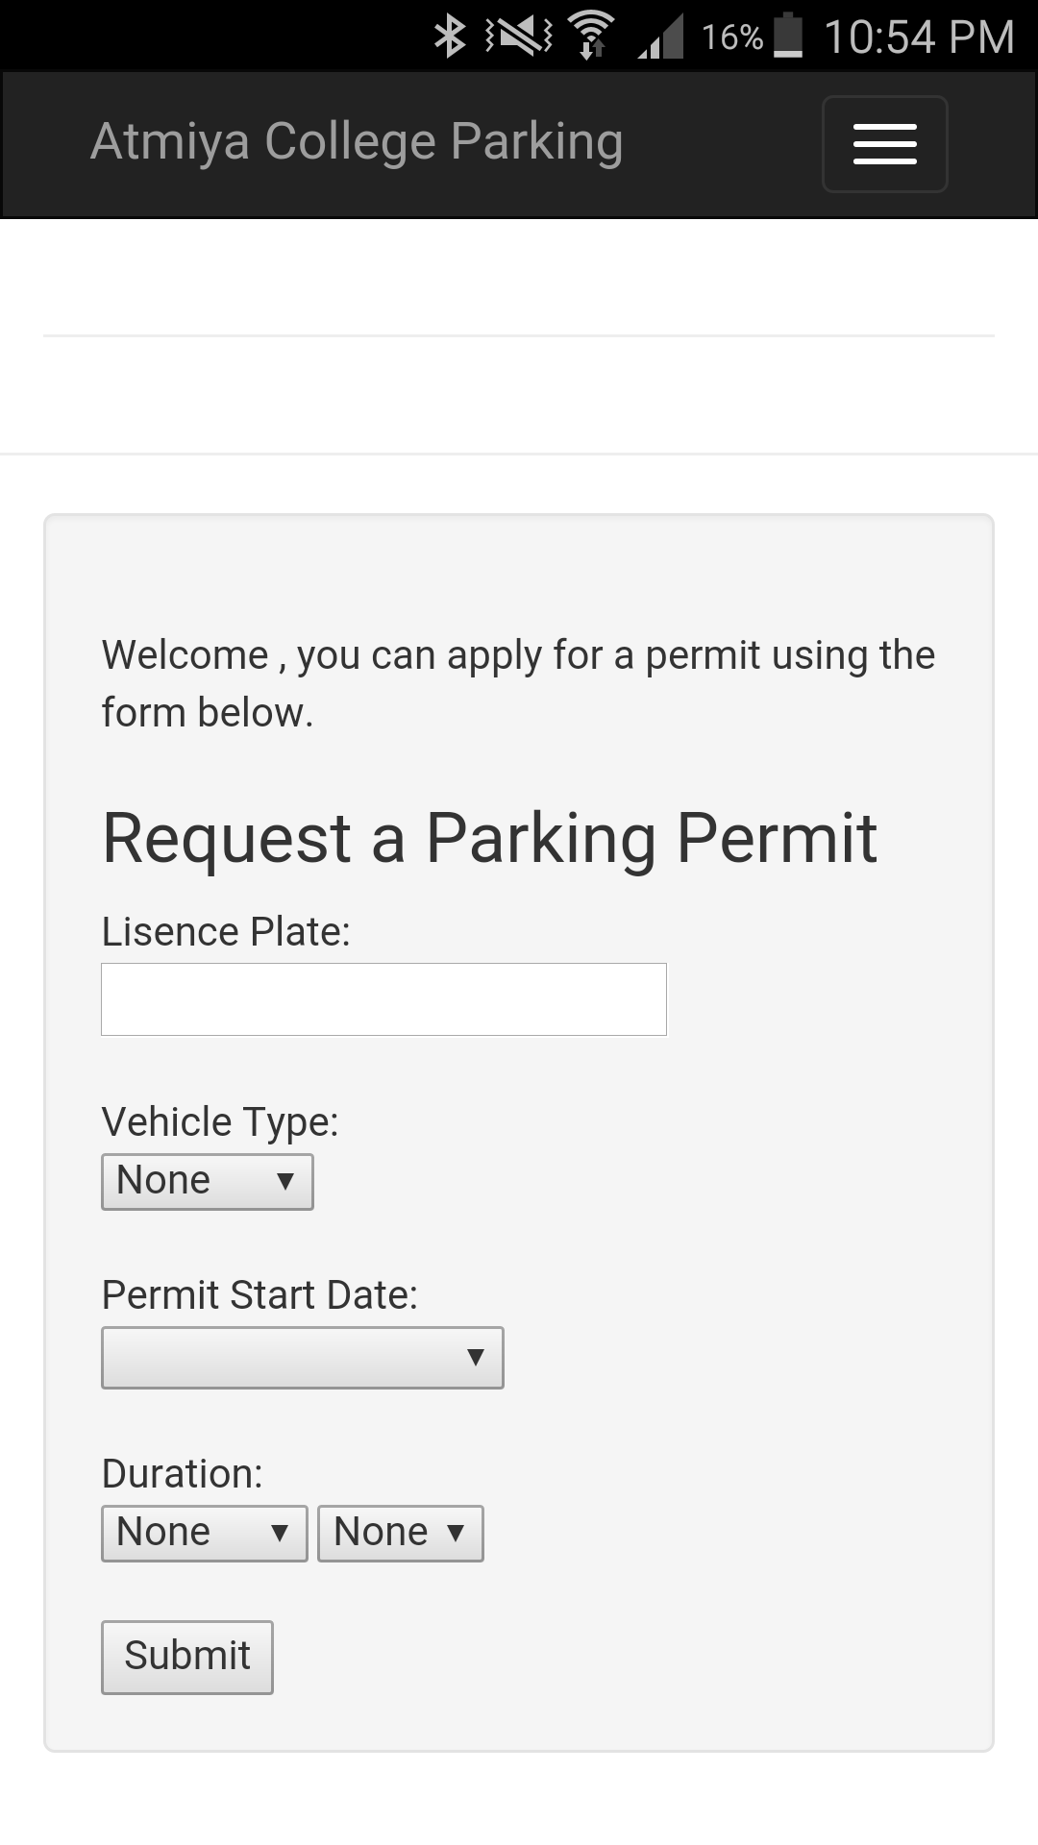

In order for the Department workers to be efficient while operating around the campus and parking lots, they will need to be able to use tablets or their phones to submit health violations, parking violations and parking permits. In order to allow them to do this we have designed the website so that when used on a phone, the website will rescale itself to fit properly onto the screen and the navigation bar will turn into a dropdown menu for higher convenience.